Part 4 : Evaluation and Final Report to the customer -

Overall statistics for the business:

Yearly Revenue

Total | Max single  Purchase | Min single  Purchase | IQR | Standard  Deviation | Average  Per Sale
£1058762 | £34000 | £1 | £4428 | £5387 | £3893

From the revenue we can see that average sale is about £3900 and that the spread is quite wide. This, coupled with the IQR shows that a high proportion of sales are clustered around the £2000-£6000. There are some high value outliers up to £34000 which are disproportionate to the average and this could help skew the data. It suggests that the business revenue is propped up by these big sales (the £34000 purchase is 3% of the whole yearly revenue) and is a risk to revenue as these high value sales are probably not the norm. The average suggests that if any sort of general discount was offered for the amount of speeding, to encourage further sales, then it should be offered at levels of £6000/£7000 as this could help push sales to above the average, which could help move some dependencies on high value purchases.

Items Sold

Total | Total in Zero Value Sales | Revised  Total | Max | Min | IQR | Standard  Deviation | Average
1681 | 162 | 1519 | 10 | 1 | 5 | 2.9 | 5.6

The average of 5.6 indicates that an average purchase typically involves multiple items, with the spread suggesting the majority of sales involve 3-8 items. Since the majority of sales involves multiple items, bulk discount could be considered for larger volume of sales or up-selling. There are 162 items that have a zero value. This could be due to promotional giveaways, replacements or free giveaways for large purchase amounts. It could be useful for the business to investigate this further as if part of a deal or bundle, need to establish just how well the promotion performed.

Items with Most Units Sold
Quantity Revenue
Name Price
HL Mountain Frame - Black 46 1349.60 24 32390.40
Lock Ring 829.80 20 16596.00
Hex Nut 4 158.00 18 2844.00
Mountain-500 Silver 48 564.99 18 10169.82
Handlebar Tube 636.80 17 10825.60
Hex Nut 22 76.40 17 1298.80
LL Road Seat/Saddle 27.12 17 461.04
Flat Washer 5 417.60 16 6681.60
Fork End 397.20 16 6355.20
ML Mountain Frame - Black 48 348.76 16 5580.16

We see that parts (including frames) make up the majority of the most sold items and that only one entry of a bike makes the top 10. If this is typical of the business, then this implies that parts are the items that move the most throughout the year.

Highest revenue generating items -
Revenue Quantity
Name Price
Mountain-100 Silver 38 3399.99 47599.86 14
Road-150 Red 48 3578.27 42939.24 12
Road-150 Red 44 3578.27 39360.97 11
Mountain-200 Black 38 2294.99 36719.84 16
HL Mountain Frame - Black 46 1349.60 32390.40 24
Mountain-100 Black 42 3374.99 26999.92 8
Road-150 Red 52 3578.27 25047.89 7
Touring-1000 Blue 50 2384.07 23840.70 10
Road-350-W Yellow 40 1700.99 23813.86 14
Mountain-100 Black 38 3374.99 23624.93 7

Bike sales make up the highest valued items by revenue with mountain bikes and road bikes being the core revenue generators. We see that HL Mountain Frame - Black 46 is a high revenue, high selling item which is not a complete bike but rather it is a frame. This potentially puts it as a key item as it acts to diversify the core products the business offers. The business moves a lot of other products (parts), again this is healthy as it shows diversity in the products customers are willing to buy and potentially an area of growth in the future due to high demand.

Products with least units sold -
Quantity Revenue
Name Price
Patch Kit/8 Patches 2.29 1 2.29
Womens Mountain Shorts L 69.99 1 69.99
Womens Tights L 74.99 1 74.99
LL Touring Seat Assembly 133.34 1 133.34
Thin-Jam Lock Nut 2 170.00 1 170.00
Blade 189.60 1 189.60
Metal Bar 1 190.80 1 190.80
LL Spindle/Axle 418.40 1 418.40
Mountain-500 Silver 52 564.99 1 564.99

Lowest revenue generating items -
Revenue Quantity
Name Price
Patch Kit/8 Patches 2.29 2.29 1
Bearing Ball 0.80 4.00 5
Mountain Tire Tube 4.99 14.97 3
LL Touring Seat/Saddle 27.12 54.24 2
Womens Mountain Shorts L 69.99 69.99 1
Womens Tights L 74.99 74.99 1
ML Touring Seat/Saddle 39.14 78.28 2
Road Bottle Cage 8.99 80.91 9
LL Mountain Pedal 40.49 80.98 2
Taillights - Battery-Powered 13.99 83.94 6

The items included within these tables produce negligible revenue and don’t sell in large enough quantities to warrant them to be included as a core item of the business. This implies that these items could be phased out of the business, bundled with other poor selling items such as patch kits with bike purchases

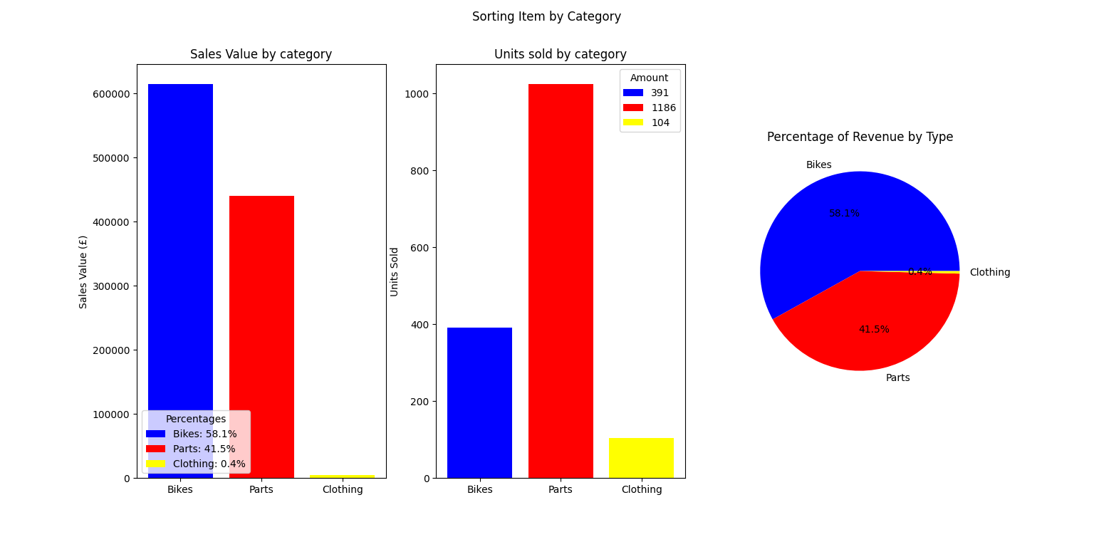
Breakdown of revenue and sales by 3 main item types.

After breaking down the data into 3 main categories, we see that parts sell the largest volume with the biggest generator of revenue for the business being the sale of bikes, however parts still generate a significant portion of the revenue which makes it almost as important for revenue as bikes.
We see that clothing is implicated as both low revenue generating and slow moving over the year. Thus it is potentially an area that needs to be reassessed in how it fits into the business, for example does the stock of clothing take up valuable storage space that would be better served producing and offering other items?. It is also worth considering how and when clothing is sold due to cycling being generally a seasonal activity.
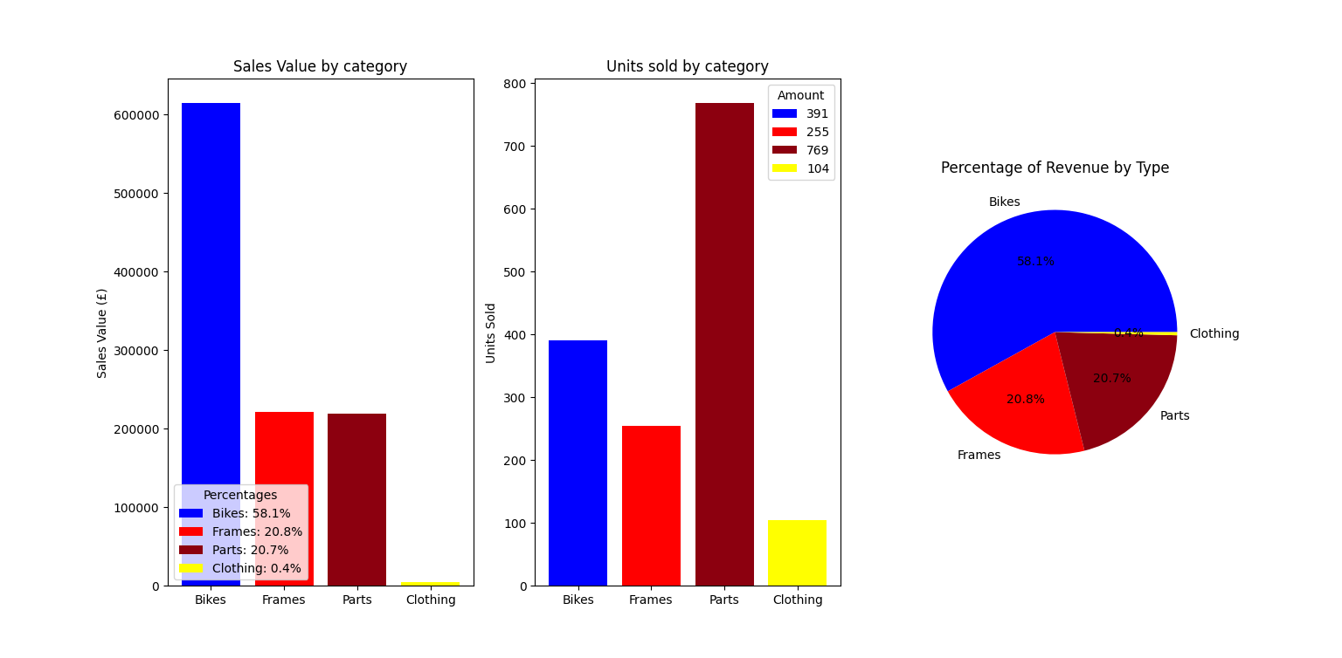
Further breakdown of categories.
Breaking down the data further by extracting items labelled frames, we see that, actually within the parts category, the sales of bike frames accounts for half of revenue of parts and other parts selling high volume for the same revenue.

Analysis by month

Revenue and sales figures by month -

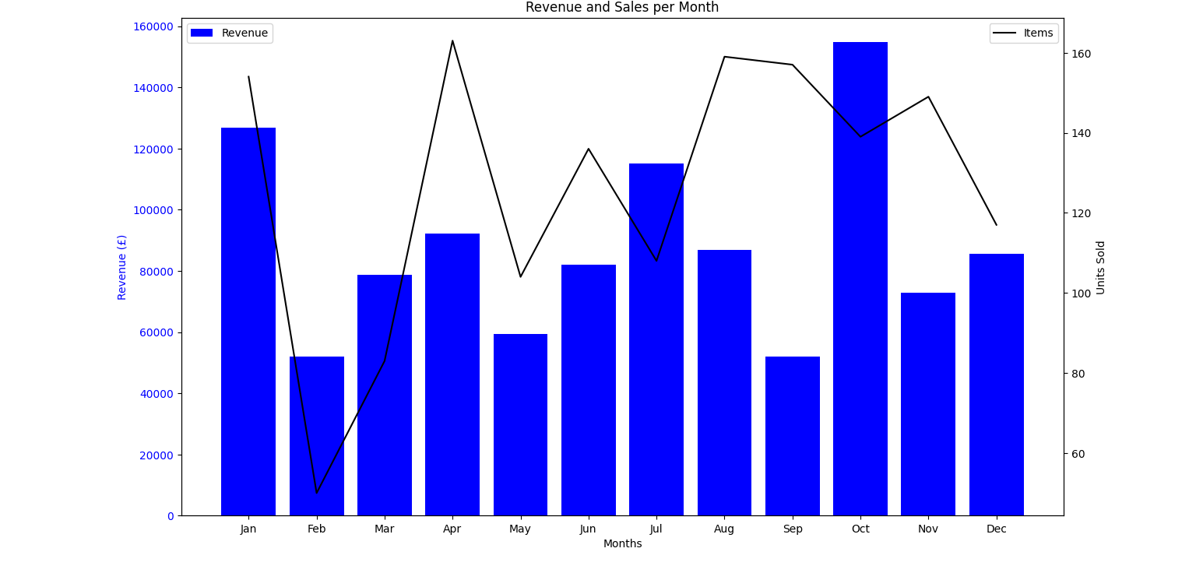Graph of revenue and sales per month
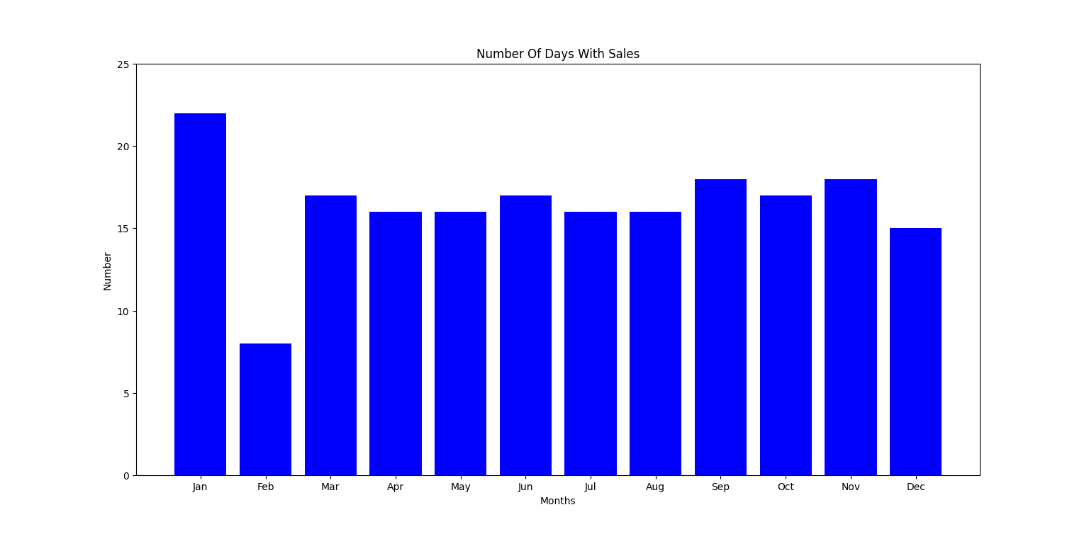
Number of days in each month with sales.

From the data, we see that the number of items sold and Revenue per month follow each other generally. This is to be expected as generally, the more that is sold, the more revenue is made.
Revenue and sales follow these general tends:

1 - In January, there is a large revenue generated, probably from bike sales. This can be explained with a ‘New Years Resolution’ sentiment. That is, as people plan to lose weight or get healthier as a New Years Resolution and cycling being a popular method to do this, it could explain higher sales figures. During this month, this sentiment should be utilized in promotions to ensure that this high revenue event continues every year.

2 - In February, there are little sales and units sold relative to the rest of the year. This could be due to people being ‘spent’ after New Year and demand in cycles in general is low. This month is a prime candidate for boosted promotions , loyalty discounts to customers or offers.

3 - The summer months and winter months produce middle of the road sales and units sold. However, in the months of April, August and September, there are a high number of units sold but lower revenue. This indicates lower value items being sold such as parts.

4 - In October, there is another spike in revenue but with lower units being sold than in April, August and September. This suggests higher valued items, which are likely to be complete bikes. This spike is probably due to the run up to Christmas.

5 - Briefly looking at the number of days with sales in each month, we see that the number of sales is constant throughout the year, however, in February there is a lower amount of active days. This could be due to the after effect of high sales in January.

Item type (Bike, parts, frames and clothing) by month -

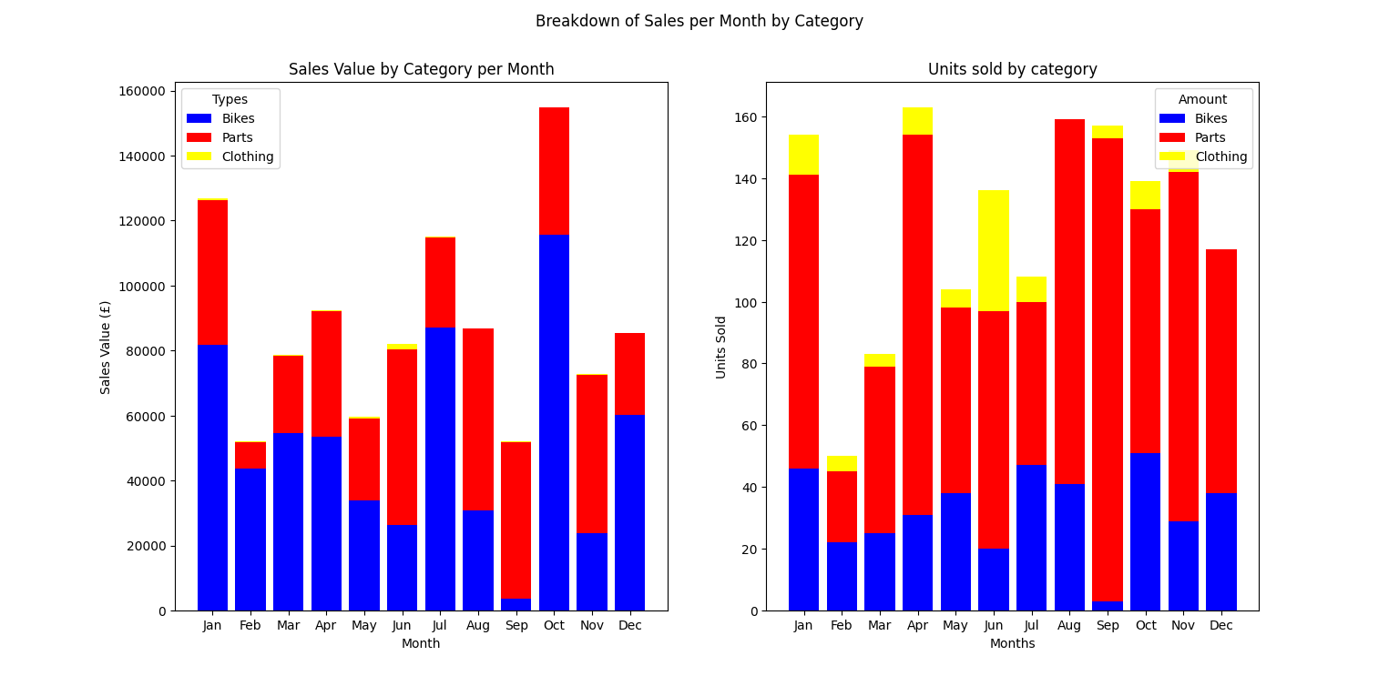Breakdown of sales and revenue by category (bikes, parts and clothing) per month
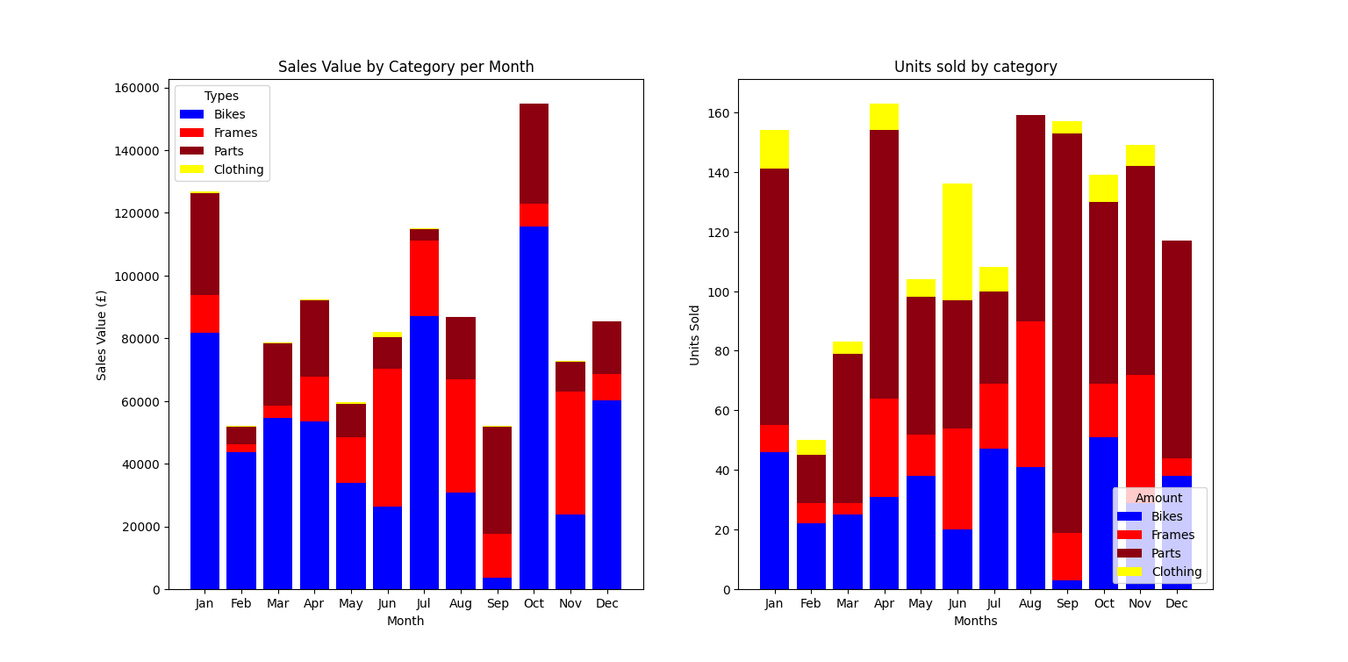
Breakdown by category that now includes frames and parts.

1 - Dividing by type we see that as predicted, the spike in January is due to sales in bikes, again likely to New Year Resolutions and fitness goals which is mirrored in part by sales in that month (people repairing their bike instead of purchasing a new one for their resolution).

2 - Sales in parts dropped to its lowest in February and increased over the remaining months of the year. Very likely due to demand no longer being strong after January (no need for parts for recently purchased or repaired bikes). Although bike sales still remain modest, likely to be latecomers to the ‘lets get healthier for the new year’ crowd. We have seen that February has the lowest sales.

3 - After the drop in February, bike sales increase incrementally until July, where they peak again and are very likely due to the summer / cycling season beginning. However sales prior to this are low.

4 - Over the summer months, part and frame sales increase much more than bike sales and peaks towards the end of summer. Most likely due to maintenance and upkeep of bicycles as they are used over the summer months.

5 - Clothing, as mentioned before, is a low revenue generating product. However, the month of June sees a spike in clothing sales. There is a market for cycling clothing during this month.

6 - The month of September is the worst for bike sales but the best for parts. This is seen as due to the fact that at the end of the cycling season, customers want to repair and fix issues before putting their bike away. This could be an opportunity to upsell new bikes as an alternative to repairing as bike sales produce more revenue per unit than parts.
7 - As expected, sales peak in October and are strong in December due to the Christmas season. Given that the new year is upon us at this stage (and potentially new bike models), this period could be used to move old or going out of production stock, in particular November. If not already doing so, then doing this as a ‘Black Friday’ event could be beneficial.

8 - First is that over the summer months, bike frame sales increase and generate healthy revenue. This again is likely to be maintenance issues and as mentioned prior, offering bundles of different parts could help further part sales.

Analysis of bikes and frames by type

Analysing bikes by ‘Mountain’, ‘Road’ and ‘Touring’ types -

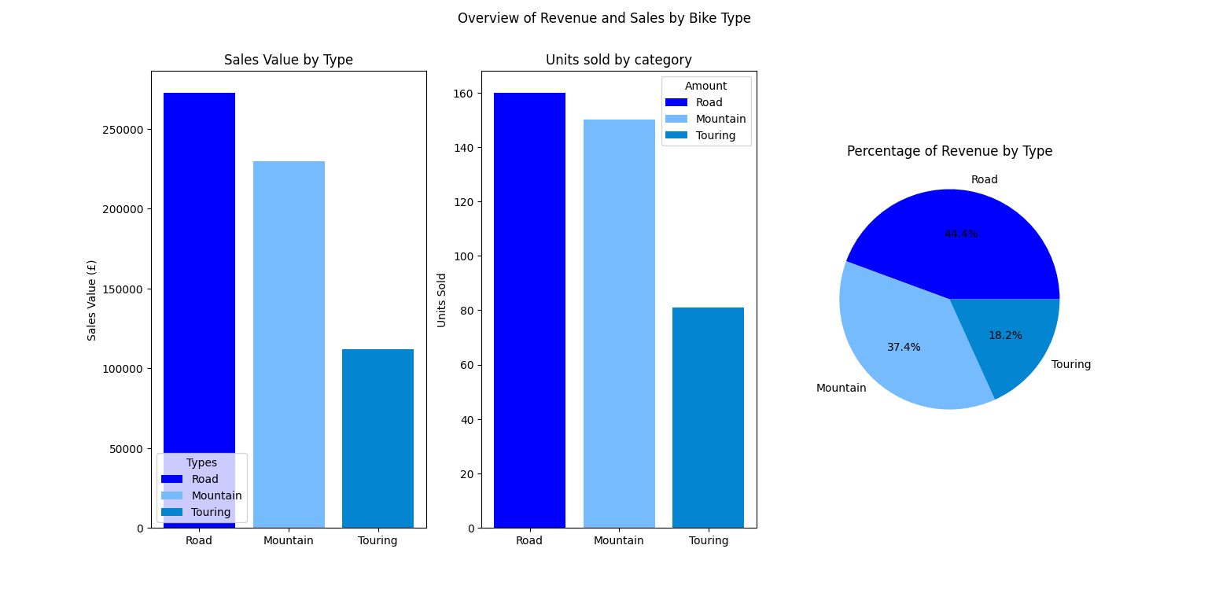
Splitting bikes by type

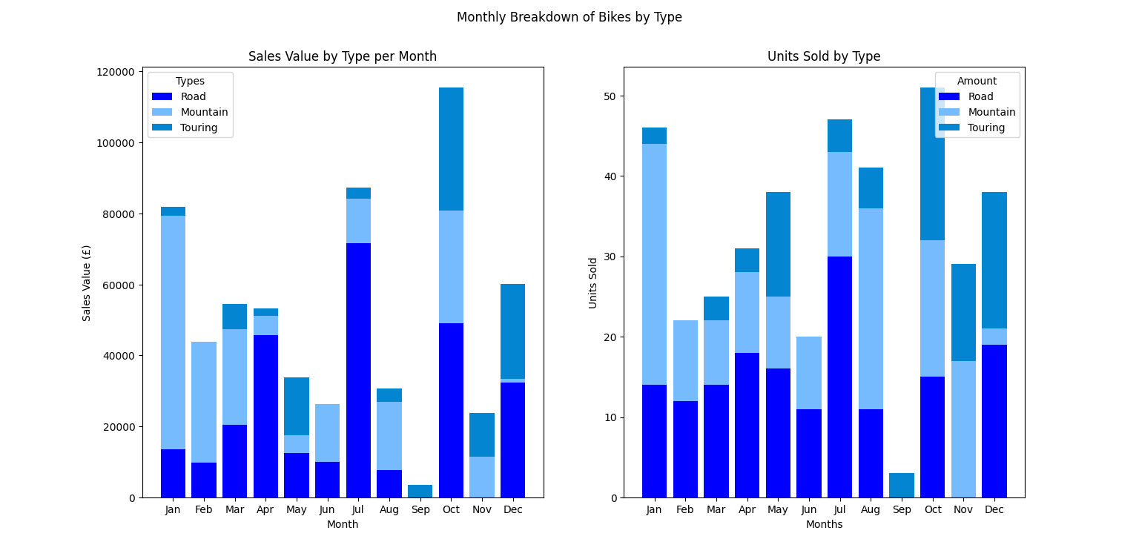
Monthly stats for bike types.

We see that mountain and road bikes sell at roughly equal amounts, however road bikes produce more revenue. This is to be expected as road bikes usually are more expensive due to the materials used in their production. Touring bikes only sell half as many (or around 20%). This would indicate that road bikes (as evidenced prior) are the biggest generator of revenue of the business. This is their core product line with a very close second being mountain bikes.

Road -
Breaking down the sales of different bike types by month, we see that not only are road bikes the biggest revenue stream and the item that sells the most, it is also the type that sells the most consistently. 10 out of 12 months have roughly even sales with a spike in July. July also has the largest revenue for road bikes. There are no sales in September, which was mentioned and there are no road bike sales, and there are no bike sales in November. This drop in sales at this time of year could be due to conditions for road cycling not being ideal due to the winter season.
Although there are consistent unit sales of road bikes across the year, there are large variations in revenue. This would suggest that the months of April, July, October and December saw sales in more expensive or premium road bikes.

Mountain -
Unit sales in mountain bikes have spikes in January, August, October and November and mid-range consistent sales from late winter until early summer. This would suggest that most mountain bikes sales arise in the latter part of the year for the business but the biggest revenue for mountain bikes comes from the first months of the year. Reasons could be that at the start of the year, premium bikes sell more whilst towards the end of the year, mountain bikes from the lower range sell. This suggests that, although mountain bikes sell all year round (bar September), there is a dichotomy in sales. Less but more expensive in the first half of the year and more but cheaper in the last 6 months of the year

Touring -
Touring bikes sell less units and generate less revenue. This may be due to touring bikes being more of a speciality bike, used for travelling (more akin to a holiday or for extended travelling). There are two periods where they sell the most. First is the last quarter of the year (Oct, Nov and Dec), probably due to Christmas. The second is in May. May may be seen as the start of the holiday season and the customers purchasing as such to fulfill demand for the coming months.

Analysing frames by ‘Mountain’, ‘Road’ and ‘Touring’ types -

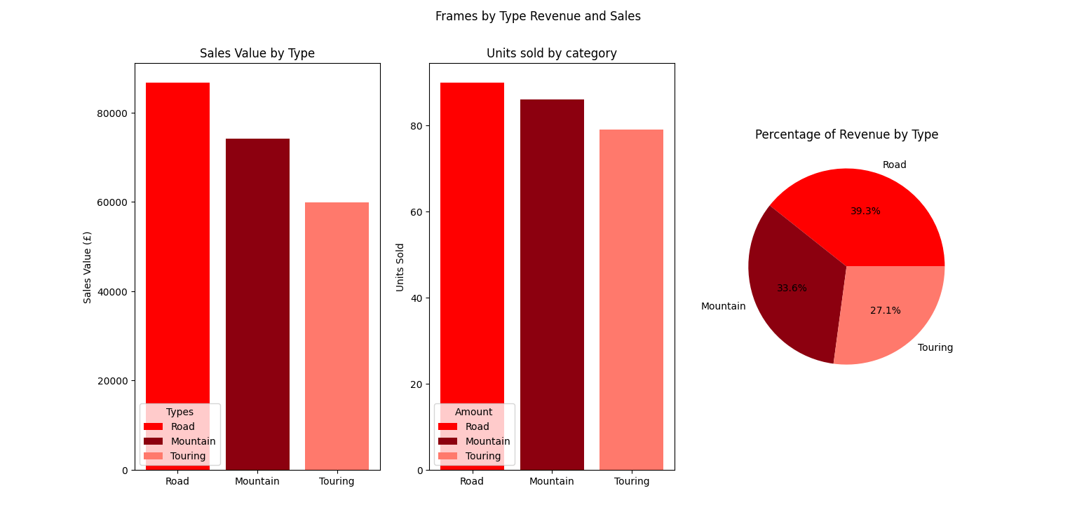
Frames by type

Unlike whole bikes that have 2 dominate types with a lesser 3rd type, bike frames are more evenly distribution for unit sales and revenue, however road bikes are still the leader in terms of revenue by around 15%.

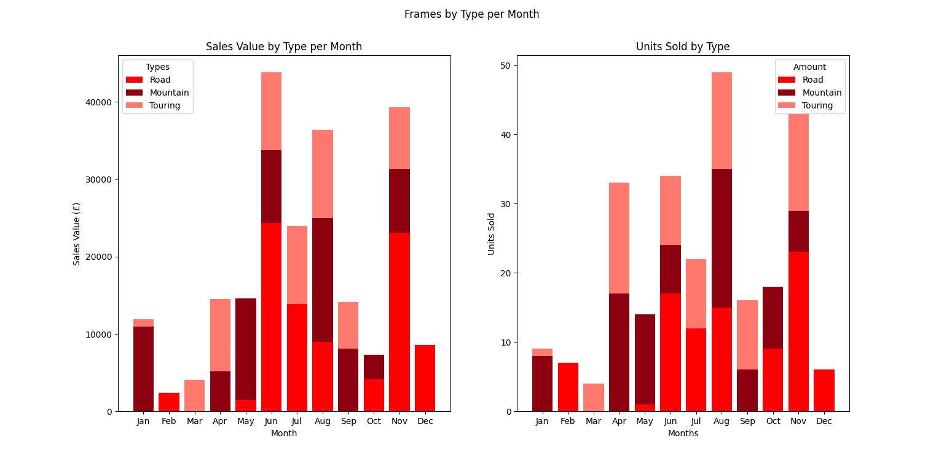
Frame type sales and revenue by type.

Majority of the sales for frames happen within the summer months. There is a spike in November and August, these are when most frames are sold.
Analysis of customer spending

Analysing spending overall -

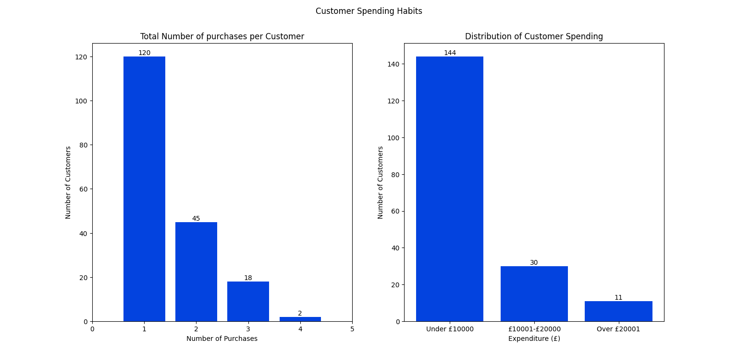
Customer spending habits with spending binned.

We can see that the majority of customers spend under £10000 (144 out of 185) with a small number spending over £10000 and only (11/185) about 6% of customers within the highest spend bracket. Most of the customers only purchase once during the year(average of 1.5 purchases) with only 65 being repeat customers. Of these returning customers, most only return once more, whilst a small fraction can be considered ‘Serial’ customers. Potentially this could indicate that retention of customers could be an issue for the business. A potential answer could be to have a customer tiering system that rewards customers for their repeat business depending on how many different purchases they make and how much they spend. Those who only purchase once and under £10000 do not receive a discount and are at the bottom of the ‘discount ladder’ and discount rate increasing for each purchase and spend level, reaching maximum discount if a customer makes 4 purchases or more AND spends over £20000.

Analysis of spending by type -

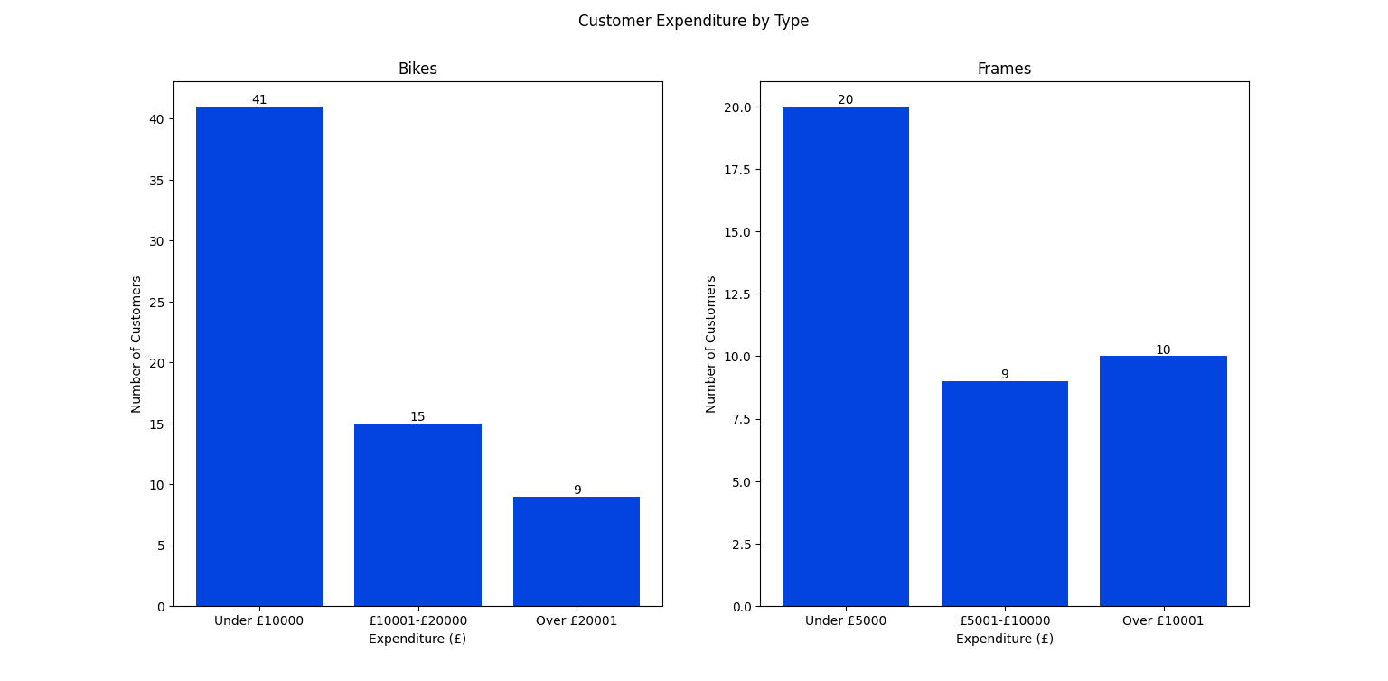
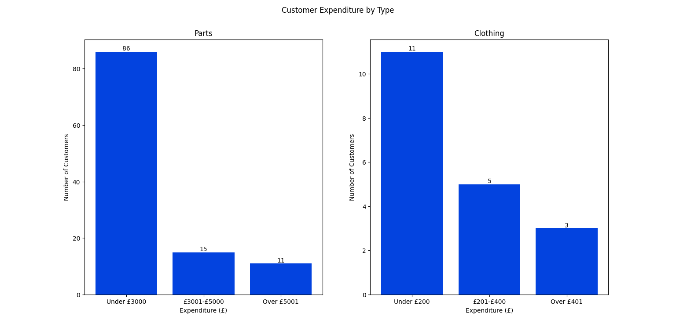
Customer spending on each type of product.

We see that over half of all customers who purchase bikes, spend less than £10000 and that only 9 (14%) of customers who purchase bikes, spend over £20000. Frames produces data that is slightly different in that, again the majority of customers spend under a certain amount (£5000), roughly equal number of customers will spend between £5001 - £10000 or over £10000.
The purchasing of parts has the greatest proportion of sales being at the lower end of the scale, with 70% of customers spending over £3000. This, coupled with many customers only making one purchase, would suggest that many customers come to the business primarily for a specific part but don't return to purchase bikes or frames which are the real profit drivers.
This could be an opportunity or area for the business to capture customer details and actively seek sales in bikes / frames at a future date from these customers. Potentially this could be done through a first time purchase offer for the customer.
Since there are a lot of one time only purchases in terms of type, each type could offer discounts on repeat customers i.e. 10% off their next purchase of frames or clothing items.

Overview analysis -

A more complete overall picture of the revenue and unit sales is that the business is a tiered structure with bikes being the dominant revenue driver with frames being a secondary source that accounts for 20% of revenue. Other parts contribute as a secondary source too but have a higher volume of sales relative to the other categories, due to lower pricing. Other parts sell more than twice as many units as other categories and thus can be seen as a filler product, something that customers potentially buy when looking for a particular part. Its customer base could be split into two types: Those who re-sell bikes as is and those who cater towards maintenance and custom build customers.
The pre-made sales of bikes are the most important and this should remain the core focus of the business, however significant effort should be placed on catering to those that want a single part or parts for maintenance as this could lead to further sales when they decide to sell bikes. Indeed many customers who purchase parts do not purchase whole bikes and so are a potential lead for bike sales in the future.
Clothing plays virtually no role in revenue generating but they do sell over 100 units. It appears to be a seasonal item, thus providing clothing for sale in the early months of summer is prudent, but then removing them as an option during the other months will free up production/space for other items.
The business follows 4 distinct periods within the year for generating profit:

1 - The first is the ‘New Year Resolution’ period at the start of the year. This period involves a lot of whole bike sales as well as substantial sales in parts.
2 - The second is the low months of February and September where sales are generally at their lowest.
3 - The summer months are predominantly the months where frames and parts sell the most. This would indicate that this period is a period of maintenance for bike owners. Sales of bikes increase too, however the revenue generated is lower, which indicates lower valued bikes being sold.
4 - The fourth period is the build up to Christmas where bike sales peak in October and see relatively strong sales in parts and bikes over the winter months.

Strengths -
Core items are bikes and frames which show that customers have confidence in producing good quality, reliable bikes resulting in a reputation that could bolster sales in the future.

The business has a diverse range of products that do sell for high revenue or high volume rates. This diversity ensures that the company is not too dependent on any single item or type and can probably weather short term drops in sales of any one of them.

Parts are a strong secondary or filler product that moves a high volume of units. As customers are generally making one purchase a year, this could potentially show that parts help to attract new customers.

The run up to Christmas show good sales, which is to be expected as bikes are often bought as gifts. Not generating a significant amount of sales during the run up to Christmas would be quite worrying!

Risks -
A high percentage of the revenue comes from high value outliers that potentially may not occur every year and may not be regular.

There are a lot of zero value transactions (10%) which appear to be parts mostly. It is important to establish the nature of the transactions such as if they are replacements, promotions or errors. Each of these possibilities have their own fallout.

Clothing does not contribute a significant level of revenue to the business and so it is possible that resources are being wasted in the production of these all year.

Bike sales are low in June and September. Although not an immediate risk, for long term stability, need to increase sales during these periods if possible.

Drop in bike sales during the last 6 months of the year compared to the first. Again for stability of revenue streams, needs to be balanced out. As Road and Mountain bikes are core products of the business, cannot restrict manufacturing of these to certain periods of the year and so ideally need to increase sales of bikes during the last 6 months of the year.

Touring bikes don't sell well during the early months of the year. Since it is quite a niche product and has sales clustered during certain times of the year, resources may be wasted producing these all year round.

Customers appear to mainly have a one time purchase and under £10000. The majority of customers appear not to be repeat customers. Parts potentially bring in new customers but the business may have a problem retaining them.

Opportunities and Recommendations -
Generally the sales of bikes ready made and frames should be the focus for the business to generate the bulk of its revenue throughout the year.

To increase average spend of a customer, increase customer retention and reduce the dependence of large revenue, one-off purchases, implement a tiered customer loyalty or discount scheme that sees discounts for returning, high spending customers.

Potential growth from part sales as they bring in new customers and could be used to generate sales of bikes (which bring in more revenue per item) in the future, maybe with the help of small discounts for customers who have not purchased a bike from the business in the past. customers due to them selling higher volumes. In particular, implementing this during the summer, leading to the second half of the year.

Review the production of clothing as an item due to low demand, if it is to remain as a standalone product, consider re-evaluate how it is marketed and sold. In particular, the product could be manufactured, marketed and sold during the summer months where there is some sales, but the resources reallocated elsewhere for the remainder of the year.

February has low sales compared to the rest of the year. Ideal candidate for discounting old stock prior to the summer season.

Future marketing and promotion campaigns could focus on the 4 main sales periods indicated prior.
1 - Focus on promotions for bikes and parts as people embrace New Year's resolutions.
2 - Generalized sales promotions for the months of September and February, to boost overall sales
3 - The summer month promotions should be ‘geared’ towards parts and frames, with the potential to reinforce customer loyalty campaigns
4 - The fourth period should focus on general bike sales due to the Christmas holidays

Other promotions and marketing campaigns could be to implement an ‘Early bird’ promotion for bikes could be implemented in June.

